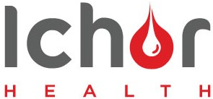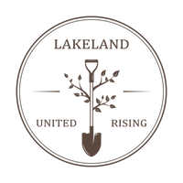
Lakeland United and Rising (LUR) has asked a private blood-testing company, Ichor Blood Services to come to the region for a Pop-Up Clinic Feb 28 – Mar 1 at East Bourne Hall on Hwy 28.
You may ask yourself, why do I need a COVID-19 Antibody Test?
“For the unvaccinated, quite simply, natural immunity has been repeatedly and consistently demonstrated to be more effective at preventing reinfection than vaccination, Mike Kuzmickas, CEO of Ichor Blood Services told Lakeland Connect. “This test offers people the opportunity to see if they have had previous exposure to SARS-COV-2 and have developed antibodies and thus some level of natural immunity.”
“For the vaccinated, the test is an opportunity to see where your antibody titres (strength) are currently at, “CEO Kuzmickas told Lakeland Connect. “On a community level, it offers the chance for a community to demonstrate potential herd immunity just as La Crete did.”
Come out and get tested and we can use the anonymous results from region to talk with the local politicians about our rights “Just Like the community of LA Crete Did!

There will be seven different tests available to the Lakeland according to ICHOR.
The Mayo Clinic Spike Protein Score
The Mayo Clinic D-dimer test
The Mayo Clinic Vitamin D test
The Mayo Clinic Prostate Health Index
The Mayo Clinic Total Testosterone Test (TTST)
The Mayo Clinic Follicle-Stimulating Hormone (FSH) test
The Mayo Clinic Lyme Disease Test
Book your Appointment Online at www.ichorbloodservices.ca
Check out our website online at www.LakelandUnitedandRising@protonmail.com

